CURRICULUM VITAE

Damanjeet Kaur
WZ-50 Ratan Park
Opp.Kirti Nagar
New Delhi-10015
(R): 011-25108514
(M) : 9278096400
(M) : 8800131190
damanjeet.cris@gmail.com

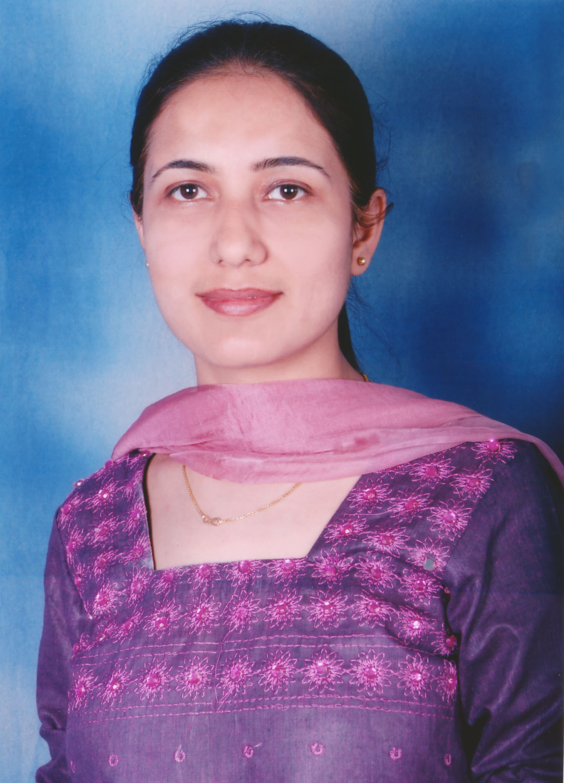

OBJECTIVE
To continue my career with an organization that will utilize my Management, Technical & educational skills to benefit mutual growth and success.

GLOBAL CERTIFICATION
- CSSP(Certified Software Security Professional)from NIELIT Gorakhpur with C Grade
- Sun certified Java professional SCJP 1.6 in 2010 with 72%

PROFESSIONAL QUALIFICATION
- ALCCS Program (equiv. to M.Tech) from IETE with B Grade 69%
- B Level from Doeacc now NIELIT with C Grade 61%
- MCA From MDU,ROHTAK with 72%
- A Level from Doeacc now NIELIT with C Grade 61%
- B. Com(p) from BMC(Bharita Mahila College) from DU

PROFESSIONAL DIPLOMA
- 2 Months Diploma of Cloud computing from IIT Kanpur
- 6 Months Diploma of .Net Technologies from NIELIT Delhi with A Grade 76%.
- Six Month Course of Advance Java from SSI Raja Garden

PROFESSIONAL EXPERIENCE
- Worked with CRIS from 26/02/2020 to 31st July 2020 as System Analyst in DLW.
- Worked with CRIS from 4/Nov/2016 to 26/02/2020 as Sr Programmer in EPS
- Worked with NIELIT as Sr Faculty (contractual) from 16/Nov/2015 to 03/Nov/2016
- Worked with DICS Janak Puri (branch of DICS TECHNOLOGIES LTD.) accredited for NIELIT O, A Level courses ,Govt of India.
- Worked with Vidya Jain Public School , Rohini as PGT(CS) from 11 April 2015 to 11 August 2015.
- Worked with Upras Vidyalay , Vasant vihar , as HOD of the Computer Science Department from 10 Dec 2013 to 10 April 2015.
- Worked with CDAC as a Guest lecturer for the Degree Course from the last Session.
- Worked with DICS Punjabi Bagh (branch of DICS TECHNOLOGIES LTD.) accredited for DOEACC O, A Level courses Govt of India and university courses (BBA,BCA) of MDU and KSOU from 25th may 1998 to 25th July 2013.

TECHNICAL SKILLS
Operating System Dos, Windows, Linux(Fedora, Ubuntu, RedHat),Apple

Database Oracle, SQL Server 2000,Ms Access, PostgreSQL, MySql

Languages
CUI Based C, C++, UNIX Shell Scripting, Data Structure with C, C++,Python
GUI Based Core Java, VB, C # , VB.Net , VC++

Internet Technologies Advance Java(JSP, Struts, Servlet, Spring, HIBERNATE), ASP.NET , PHP, Django Python

Front end Technology Bootstrap 4.0

Mobile Technologies Android on Eclipse and also on Android Studio, Flutter(Dart) on Android Studio, Basic idea of iOS with Flutter and Swift

VM Environments Virtual Box, Hyper-V, VMware

WEB SERVER Apache, Xamppp, Wamps, EasyPhp, File Zilla, Web Logic, Tomcat, IIS server

Server Enviornment Linux Web Server Configured for PHP in VM
Configuration env in NIELIT for academic purpose.

Web Service Rest and Soap Web Service knowledge in Java for Mobile Apps, Tibco(ESB Solution) and Python

Cryptography Technique: Stegnography , Digital Signature

Version Control SVN, GIT

Cloud Technology GCP (Google Cloud Platform)

Conceptual Knowledge: SSAD, Software Engineering, SPM (Software Project Management), SQM(Software Quality Management), Software Testing ,Networking, Internet Security, Mobile Communication, AI, Discrete Mathematics, DBMS, Computer Organization(CO), Operating System, Computer Graphics.

PROJECT’S OVERVIEW

Project # 5

Project Title : DLW Erp Solution
Client : Indian Railways
Role : Analyses and Development
Language : Django/PostgreSQL
IDE : Visual Studio Code

Description:
The Diesel Locomotive Works in Varanasi, India, is a production unit of Indian Railways. DLW stopped manufacturing Diesel locomotives in March 2019 as IR is moving towards 100% electrification of its rail network. Currently DLW produces only electric locomotives.

Project # 4
Project Title : Aapoorti (MobileApp)
Client : Indian Railways
Role : Developer
Language : Java/ Dart
IDE : Android Studio
Description:
Indian Railway Electronic Procurement System (IREPS) Mobile App आपूर्ति is for Android and iOS users. The app provides information related to e-tenders and e-auction (Sale) pertaining to Indian Railways and other PSUs who are using IREPS portal.

Project # 3
Project Title : Aapoorti (MobileApp) Web-Services
Client : Indian Railways
Role : Developer
Language : Java
IDE : Eclipse
Description:
Indian Railway Electronic Procurement System (IREPS) Mobile App आपूर्ति is for Android and iOS users. The app provides information related to e-tenders and e-auction (Sale) pertaining to Indian Railways and other PSUs who are using IREPS portal. The aim of this web service is to display data on mobile.

Project # 2
Project Title : IREPS
Client : Indian Railways
Role : Developer
Technologies : Java
Framework : Struts
IDE : Eclipse
Description:
Indian Railway Electronic Procurement System (IREPS) is the Application Software of Indian Railways for online activities for procurement of Goods, Works & Services, Sale of Materials, and Leasing of Assets through the process of E-Tendering, E-Auction or Reverse Auction. The application is divided in different work areas depending upon the nature of activity viz. Goods and Services, Works, Leasing, Auction Sale etc.

Project # 1
Project Title : IREPS Helpdesk
Client : Indian Railways
Role : Developer
Technologies : Java/J2EE, spring MVC and JDBC, JSP, JSTL
Platform : Windows 10
Application Server : JBOSS Server
IDE : Eclipse

Database : Oracle 12c

Description:
The Help Desk is the module of the E-Procurement system (EPS) application of Indian railways which provides the facility to Vendors, Railway users and others to get help if they face any problem at the time of using the application, or if they have any query regarding the application.

Project # 0
Project Title : Summate Express Accounting solution
Client : FCML
Role : Developer
Technologies : C#
Platform : Windows 10
IDE : Visual Studio

Database : SQL SERVER

Description:
The Summat Express Accounting solution is the module of the FCML Window
based application which provides the facility to manage the account records on the basis of client server environment.

DISSERTATION DETAILS
Successful Completed dissertation for ALCCS program in Java for “A framework for authentication of Web Document Using Digital Signature” under the guidance of Mr. Ajeet Saha (Technical Director in NIC).

ACHIEVEMENTS
- Won 3rd prize in Writing Competition at Gurgaon District level
- Participated in Poem Competition at School level.
- Participated in Scout & Guide and won 2nd prize in co-operation and coordination.
- Participated in easy competition at the college level.

Publication Details

Title Published In
- NKC Recommendation UGC 2daysNational Seminar
- Dimensions of Professional Education SFS International Seminar
- Role ICT in higher Education UGC 3daysNational ,DU
- Right to Education SFS seminar, IP Univ
- Cloud Computing SFS Seminar, IP Univ
- Dream of Digital equity for equality CBSEQuarterly BulletinApril-june2014

Book Published
- “Application of .net Technology” published by Yash Publication
- Question Bank of A level Courses subject with new Syllabus by Yash Publication through 2009 Dec

Employment newspaper Publish Details
- Article “career in safer sky” about career in cloud computing in 16-21 June 2012
- Article “Carrer in Internet Marketing” about SEO, SMO and other internet marketing details in 8-14 Feb 2014.

Professional Profile
- Present myself as a Developer for different technologies . Enhancing the skills.
- Got the opportunity to present myself as a corporate trainer in Nielit
- Got the opportunity to perform 2 times as External Practical Examiner in IP University Colleges.
- From last 11 years worked as Practical Examiner and as well as Project Guide for the NIELIT (Doeacc) A level Diploma.
- As a Faculty provide classes for O/A Level for All subjects, and also involve in the training of Advance Courses Such as .Net, Advance Java, Java, Php , Android .

PERSONAL DETAILS

Father Name : Sh R.S.Chadha
Father Occupation : Ex-servicemen
Date of Birth : 19th October 1977
Language Known : English, Hindi, Punjabi
Hobbies : Net Surfing, Listening Music, Reading Books
Marital Status : Single
Gender : Female
Religion : Sikh

I hereby declare that all the statements mentioned above are true to the best of my knowledge.

Date:
Place: New Delhi (Damanjeet Kaur)

